Dissolving & Diffusion

Method: Carefully put a purple crystal of potassium permanganate (solute) into a beaker of water (solvent) using a hollow glass tube. Do not move the beaker but check it after 5 and 15 minutes

Draw three particle diagram below to explain what is happening to the solution over time.

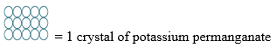 | 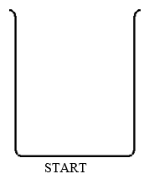 | 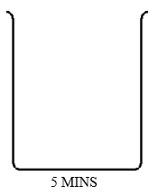 | 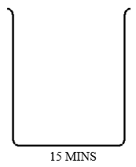

2. Explain what is happening to the particles in your diagram. Try to use as many of the following words as possible.

solvent | diffusion | move | particles | solution | dissolves | spreads | water | solute

3. How could you speed up the processes taking place in the beaker in the experiment above?
Explain why this would speed it up in terms of the energy of the particles involved.

4 Label the following gas jars after the experiment after the cover slip is removed:
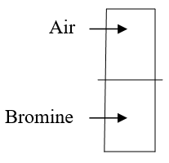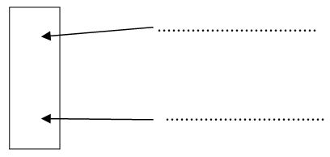

5 Diffusion happens faster in gases than in liquids. Explain why this happens.

